Question 1
Recreate the following website using HTML (without using CSS).
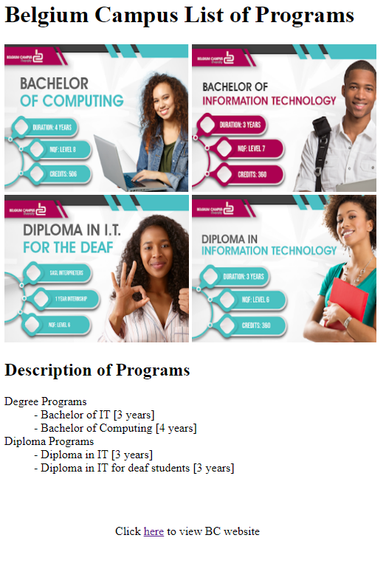
To create this, utilize the following instructions
- Download and utilize the images in the bcprograms folder on Teams (relative URLs).
- Set width and height of images to 250px and 200px respectively
- Headings should be H1 and H2
- Set URL of link to point to: https://www.belgiumcampus.ac.za, and it should open in a new tab
- The last line with the link should be indented, 150px from the left margin
MEMO Q1
